**SMALLEST NUMBER IN AN ARRAY**  
  
**EXP NO: 8**

**AIM:** To find the smallest number from an array using 8085 processor.

**ALGORITHM:**  
1) Load the address of the first element of the array in HL pair.  
2) Move the count to B register.  
3) Increment the pointer.  
4) Get the first data in A register.  
5) Decrement the count.  
6) Increment the pointer.  
7) Compare the content of memory addressed by HL pair with that of A register.  
8) If carry=1, go to step 10 or if carry=0 go to step 9  
9) Move the content of memory addressed by HL to A register.  
10) Decrement the count.

**PROGRAM:**  
LXI H,2050  
MOV C,M  
DCR C  
INX H  
MOV A,M  
LOOP1: INX H  
CMP M  
JC LOOP  
MOV A,M  
LOOP: DCR C  
JNZ LOOP1  
STA 2058  
HLT

**INPUT:**

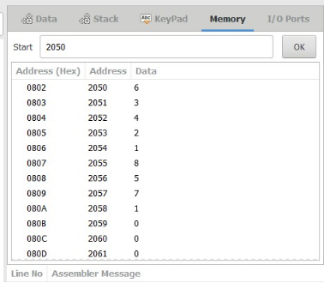

**OUTPUT:** 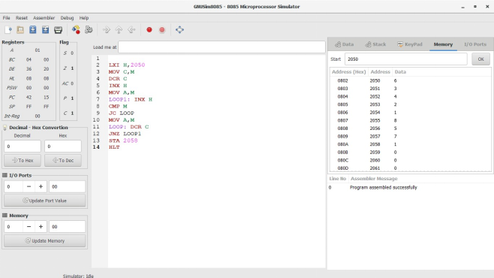

**RESULT:** Thus the program was executed successfully using 8085 processor simulator.